

Student Name……………………………………

FURTHER MATHEMATICS

TRIAL EXAMINATION 1

2006

Reading Time: 15 minutes
Writing time: 90 minutes

Instructions to students
This exam consists of Section A and Section B.
Section A contains 13 multiple-choice questions from the core, 'Data Analysis'.
Section A is compulsory and is worth 13 marks.
Section B consists of 6 modules each containing 9 multiple-choice questions. You should choose 3 of these modules and answer every question in each of your chosen modules.
Each of the modules is worth 9 marks.
Section B begins on page 9 of this exam.
There is a total of 40 marks available for this exam.
Unless otherwise stated the diagrams in this exam are not drawn to scale.
Students may bring one bound reference or one text that may be annotated or one lecture pad into the exam.
A graphics or CAS calculator may be used in the exam.
An answer sheet appears on page 37 of this exam.
Formula sheets can be found on pages 35 and 36 of this exam.

This paper has been prepared independently of the Victorian Curriculum and Assessment Authority to provide additional exam preparation for students. Although references have been reproduced with permission of the Victorian Curriculum and Assessment Authority, the publication is in no way connected with or endorsed by the Victorian Curriculum and Assessment Authority.

© THE HEFFERNAN GROUP 2006
This Trial Exam is licensed on a non transferable basis to the purchaser. It may be copied for educational use within the school which has purchased it. This license does not permit distribution or copying of this Trial Exam outside that school or by any individual purchaser.
Section A

Core

All questions must be answered.

The following information relates to Questions 1 and 2.

The marks obtained by students in a Year 7 class for a book review are displayed as an ordered stemplot below.

0* | 3
0
1* | 2 | 4 | 4
1 | 6 | 6 | 7 | 7 | 7 | 8 | 8 | 9 | 9
2* | 0 | 2 | 2 | 3 | 4
2 | 5 | 7 | 9
3* | 0 | 0

Question 1

The number of students in the Year 7 class is

- 21
- 23
- 26
- 27
- 30

Question 2

The mode mark obtained was

- 1
- 6.32
- 7
- 17
- 19.65

Question 3

Each member of a group of university students was asked how many people lived in the house where they resided.
The results are displayed on the dot plot below
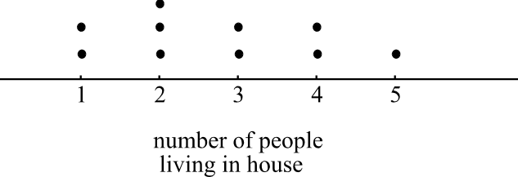

What percentage of the group had less than four people living in their house?

7%
- 10%
- 70%
- 90%
- 100%

Question 4

The heights of some genetically modified plants, grown in a laboratory, have a normal distribution with a mean of 62cm and a standard deviation of 3cm.
The percentage of plants that have a height between 59 and 65cm is

- 34%
- 47.5%
- 50%
- 68%
- 95%

Question 5

The price paid per square metre for new strata offices in a business park is displayed on the box plot below which has one possible outlier.
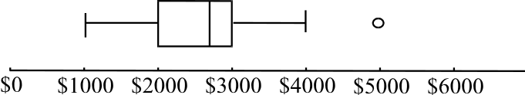

The piece of data with the value 5000 has been identified as a possible outlier because it is

less than 6000
- greater than 2700
- greater than 3000
- greater than 4000
- greater than 4500

Question 6

The level of training undertaken by junior football teams was investigated by the league. A sample of 176 junior teams provided information about their age group and the number of training sessions held per week. The data collected is shown in the table below.

Level of  training | Age Level
Level of  training | Under 12 | Under 14 | Under 16 | Under 18
Once a week | 31 | 16 | 25 | 7
Twice a week | 17 | 19 | 15 | 22
Three times a week | 6 | 3 | 4 | 11

The percentage of Under 16 teams that train twice a week is closest to

- 3%
- 9%
- 21%
- 27%
- 34%

The following information relates to Questions 7 and 8.

The height of ten people together with their arm lengths (measured from the underarm to the tip of the longest finger) is displayed on the scatterplot below.

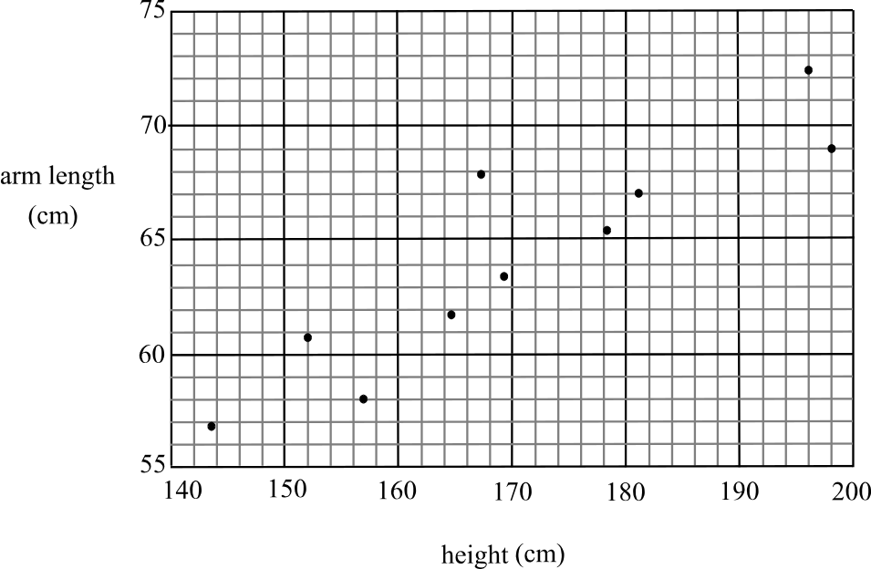

Question 7

The variable height, could be described as

- a categorical variable
- a discrete variable
- the dependent variable
- the independent variable
- a negative variable

Question 8

A three median line is fitted to this data and has a gradient of

- 0.25
- 0.32
- 0.47
- 2.31
- 4

Question 9

A summary of the results for Kate’s classes in the French and Maths exams are shown in the table below.

 | Class mean | Class standard deviation
French | 62% | 7%
Maths | 71% | 5%

Kate obtained 65% in both exams.
The difference in her z-scores is

0.14
- 0.36
- 0.77
- 1.21
- 1.63

Question 10

A time series plot is shown below.
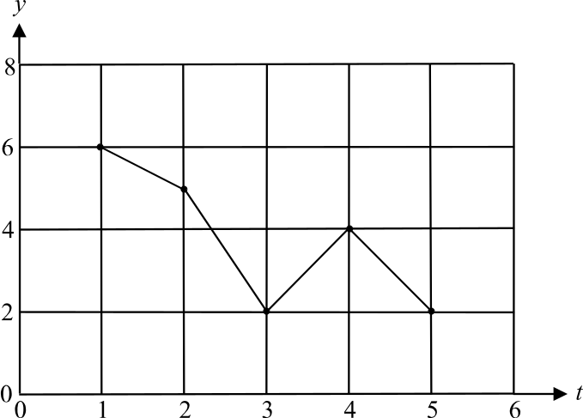

This time series is to be smoothed using the three median smoothing method.
Which one of the following coordinates would appear on the smoothed plot?

- (1,5)
- (2,4)
- (3,3)
- (4,2)
- (5,4)

Question 11

For a car rental business, rentals in the first quarter are typically above the yearly average and rentals in the third quarter are typically 20% below the yearly average.
Which one of the following tables could be the seasonal indices for the business?

 | Quarter 1 | Quarter 2 | Quarter 3 | Quarter 4
Seasonal  index | 1.39 | 0.87 | -0.20 | 1.94

 | Quarter 1 | Quarter 2 | Quarter 3 | Quarter 4
Seasonal  index | 1.05 | 1.32 | 0.80 | 0.83

 | Quarter 1 | Quarter 2 | Quarter 3 | Quarter 4
Seasonal  index | 0.82 | 1.43 | 0.20 | 1.54

 | Quarter 1 | Quarter 2 | Quarter 3 | Quarter 4
Seasonal  index | 1.03 | 0.96 | 0.80 | 1.17

 | Quarter 1 | Quarter 2 | Quarter 3 | Quarter 4
Seasonal  index | 0.80 | 1.29 | 1.31 | 0.6

The information below relates to Questions 12 and 13.

The time series plot below shows the profit for a resort each quarter over a period of five years. A trend line has been fitted to the data by eye.

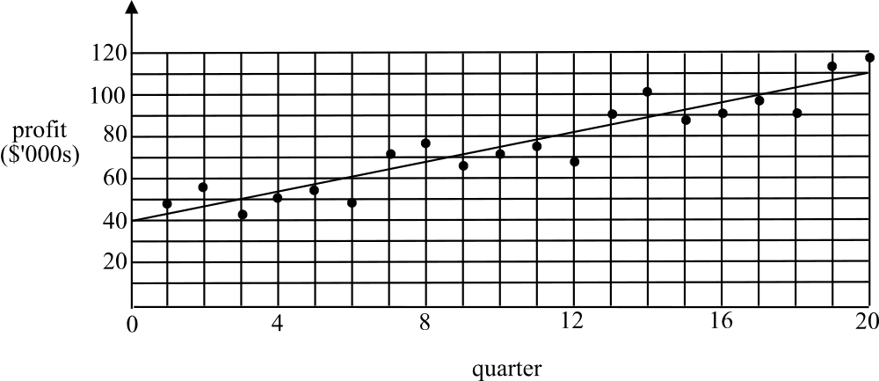

Question 12

The profits for the resort over the five year period show

- cyclical variation
- random variation
- seasonal variation
- downward trend
- negative trend

Question 13

The equation of the trend line shown is

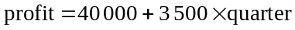.

The first quarter represents the January – March quarter of 2001.
According to the trend line that has been fitted, the profit forecast for the resort for the July – September quarter of 2008 is

- $134 500
- $145 000
- $148 500
- $152 000
- $162 500

Section B

Module 1: Number Patterns

If you choose this module all questions must be answered.

Question 1

For the sequence 1, 5, 9, 13,… the sum of the first twenty terms is

- 77
- 780
- 820
- 1560
- 3665

Question 2

Harrison deposited his birthday money and then $3 each week into his school bank account. No other deposits or withdrawals were made. After nine weeks he had $73 in his account. After seventeen weeks the amount in his account would be

- $24
- $46
- $93
- $97
- $100

Question 3

The fourth term of a geometric sequence is 54 and the third term is 18. The first term of the sequence is

- 2
- 3
- 6
- 486

Question 4

The sum of the infinite geometric sequence 4.2, -2.1, 1.05, -0.525,… is

- -2.8
- -0.5
- 2.8
- 3.1
- 8.4

Question 5
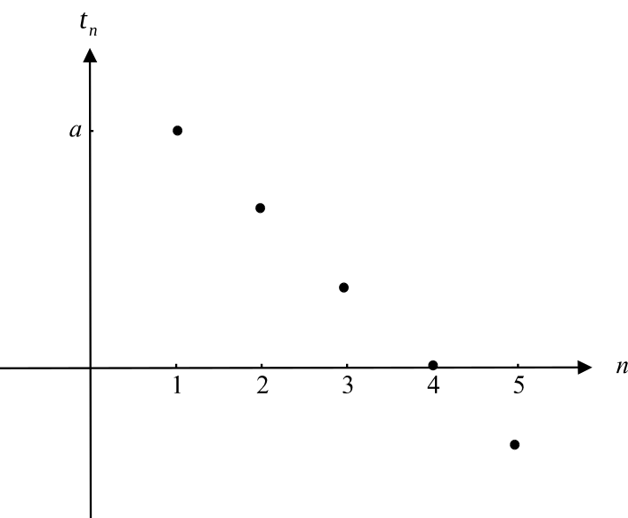

The first five terms of a sequence are shown on the graph above.
The sequence is most likely to be

- arithmetic with 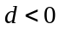
- arithmetic with 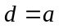
- arithmetic with 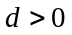
- geometric with 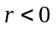
- geometric with

Question 6

In the first week of it's operation, a recruitment company has seven positions to fill. The aim of the company each week is to double the previous week’s number of positions to fill and add five more.
Let 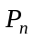represent the number of positions the company has to fill in the nth week. The difference equation that describes the company’s aims is

- 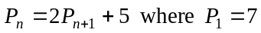
- 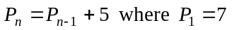
- 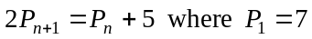
- 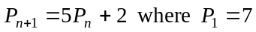
- 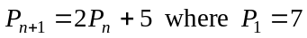

Question 7

A sequence is generated by the difference equation

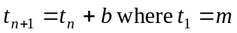.

Which one of the following statements must be true?

- The sequence is increasing.
- The second term is positive.
- The common difference of the sequence is b.
- The common ratio of the sequence is .
- The common ratio of the sequence is b.

Question 8

The number of feral cats living in the state forest is thought to be increasing by 2% each year. The initial estimate of the number of feral cats living in the forest is sixty.
Let 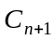 represent the number of feral cats living in the state forest n years after the initial estimate is made.
Which one of the following difference equations generates the estimated number of feral cats living in the forest over successive years?

- 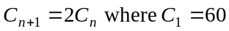
- 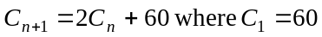
- 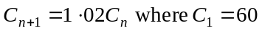
- 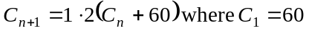
- 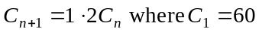

Question 9

A sequence has the rule 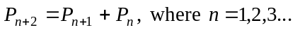
Also 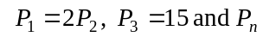 represents the 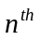 term of the sequence.
The fourth term of the sequence is

- 5
- 10
- 15
- 20
- 25

Module 2: Geometry and trigonometry

If you choose this module all questions must be answered.

Question 1
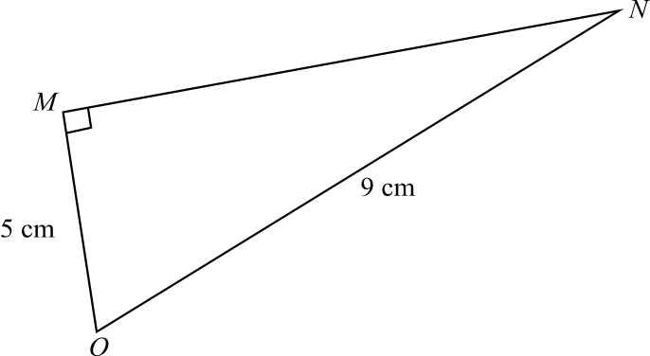

For triangle MNO, the angle MNO is closest to

- 1°
- 6°
- 29°
- 34°
- 56°

Question 2

A concrete pipe is in the shape of a prism of length 8m. The cross-section of the pipe is a square with a circular hole of diameter 0.6m through its centre.
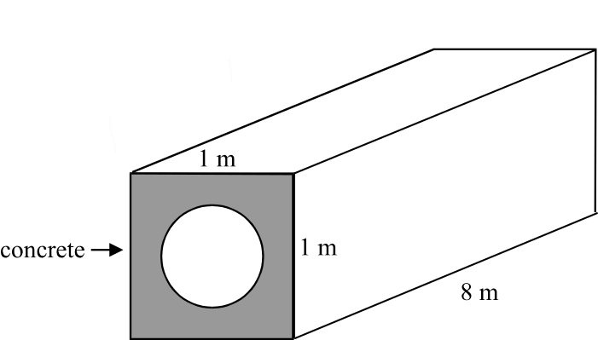

The volume of concrete in the pipe is closest to

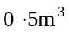
- 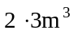
- 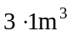
- 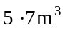
- 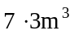

Question 3

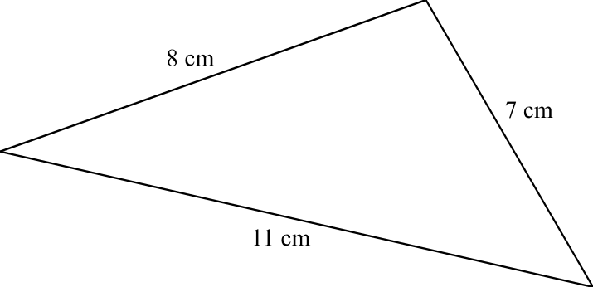

The area of the triangle shown above is closest to

- 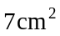
- 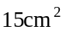
- 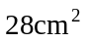
- 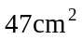
- 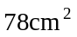

Question 4

From the window of an office building, a worker sees a tram in the distance. The horizontal distance between the base of the building and the tram is 400m and the angle of depression of the tram that is sighted is 15°. The vertical distance of the worker above the base of the building in metres is closest to

- 107
- 187
- 414
- 1492
- 1545

Question 5
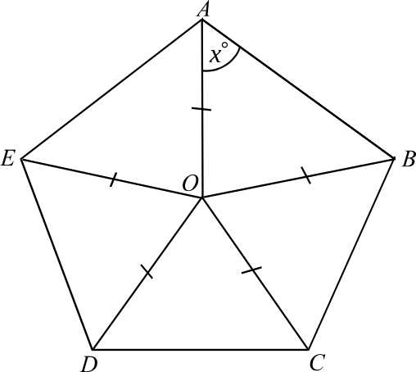

In the diagram, ABCDE is a regular pentagon. The value of x is

- 36°
- 54°
- 60°
- 72°
- 108°

Question 6
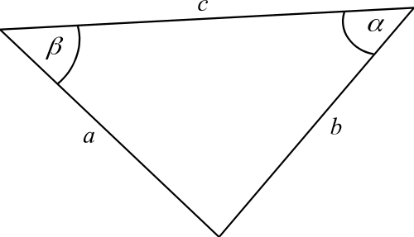

Which one of the following statements is true?

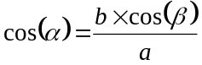
- 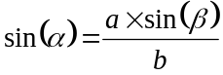
- 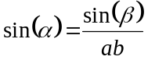
- 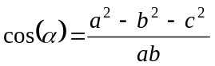
- 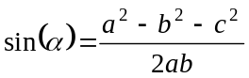

Question 7
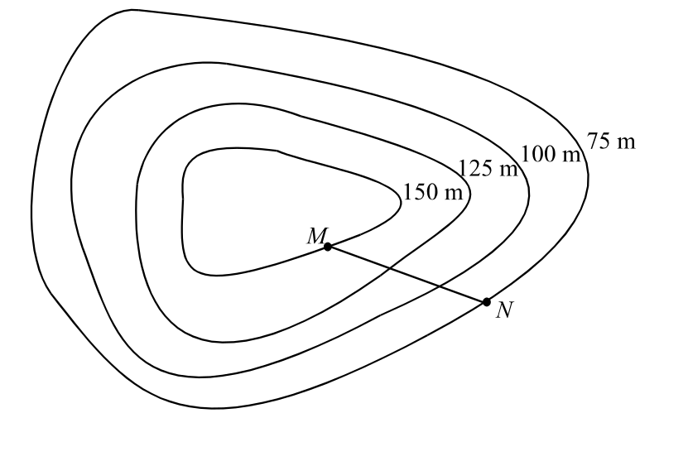

On a contour map of a hill, the average slope of the line MN is 0.2. The horizontal distance between the two points M and N is

- 30m
- 75m
- 300m
- 375m
- 750m

Question 8

Tuna comes in similarly shaped cylindrical cans in two sizes.

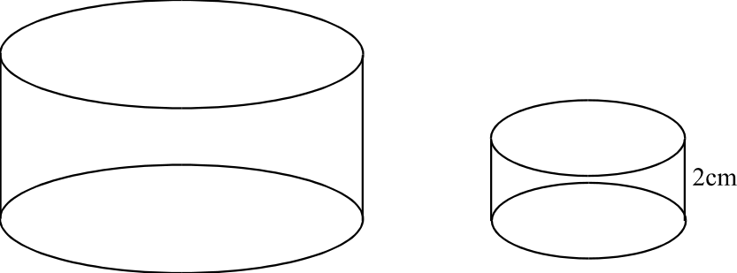

The volume of the small can is 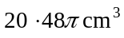 and the volume of the large can is 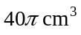. The height of the small can is 2cm. The height of the large can will be

- 1.4cm
- 1.95cm
- 2.5cm
- 2.8cm
- 3.91cm

Question 9

Two right pyramids with square bases are shown below.

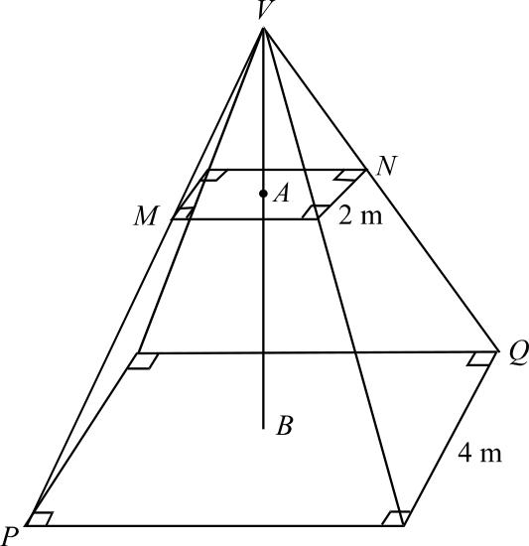

Point A is the centre of the base of the small pyramid.
Point B is the centre of the base of the large pyramid.
The sidelengths of the base of the large pyramid and the small pyramid are 4m and 2m respectively.
The length of BV is 6m.
The length of AV is

- 1.5m
- 2m
- 3m
- 3.5m
- 4m

Module 3: Graphs and relations

If you choose this module all questions must be answered.

Question 1

The point 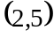 lies on the line 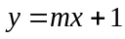.
The value of m is

1
- 2
- 3
- 4
- 5

Question 2

The graph below shows the cost of a massage up to 90 minutes long.

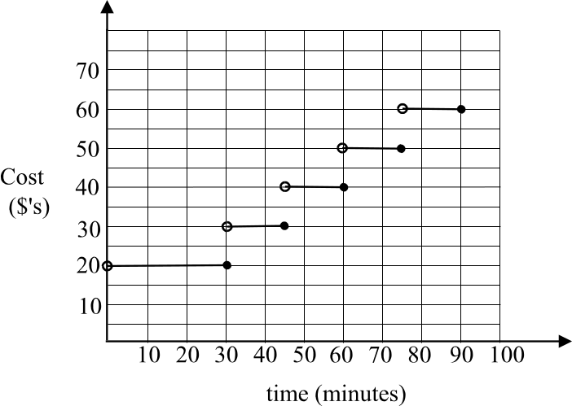

Jane has a 20 minute massage and Kate has a 50 minute massage. The total cost for the two ladies is

- $20
- $30
- $40
- $50
- $60

Question 3

The lines 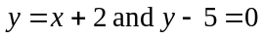 intersect at the point

- 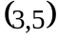
- 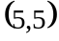
- 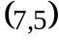
- 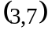
- 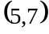

Question 4

The equation of the straight line that passes through the points 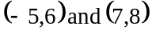 is

- 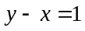
- 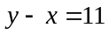
- 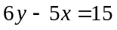
- 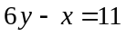
- 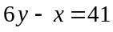

Question 5

Marita bought 6 small steak pies and 2 large apple pies for a total of $22.60. At the same shop, Angela bought 5 small steak pies and 3 large apple pies for a total of $23.90. The cost of 1 large apple pie would therefore be

- $2.50
- $2.70
- $3.00
- $3.80
- $4.20

Question 6
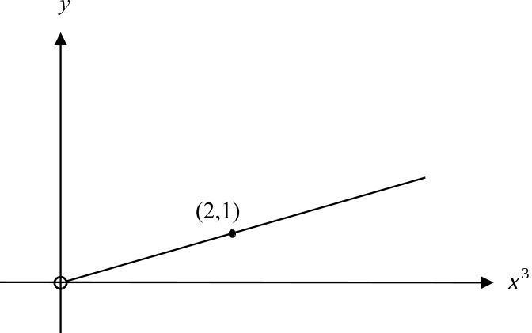

The graph of the relation 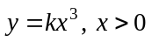 is shown above.
The value of k is

- 2
- 8
- 16

Question 7

The graph of the relation 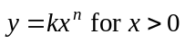 is shown below.
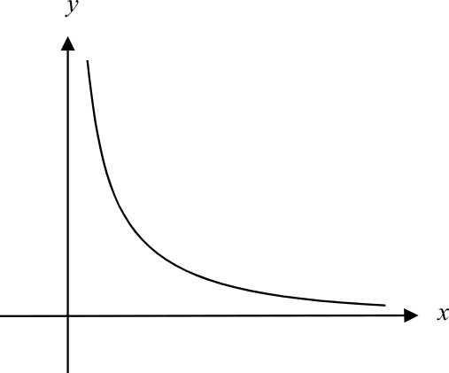

Which one of the following is true?

- the value of k could be negative.
- the value of k could be zero.
- the value of n could be – 2 or – 1.
- the value of n could be 1 or 2.
- the value of n could be 3.

Question 8

The shaded region (with boundaries included) represents the feasible region for a linear programming question.
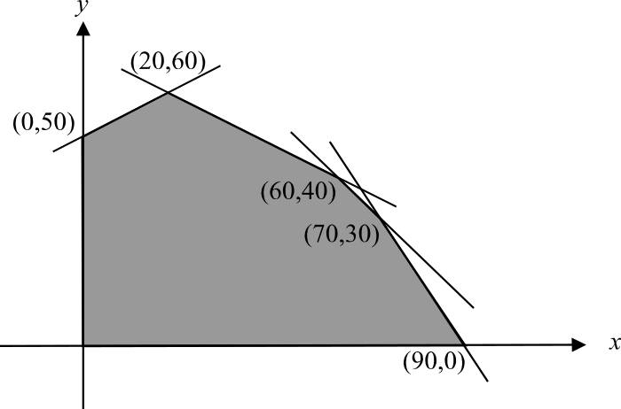

The objective function is 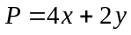.
The maximum value of P occurs at

- 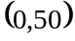
- 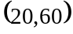
- 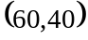
- 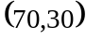
- 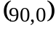

Question 9

Pauline is a fitness fanatic who spends at least 5 hours a week doing lapwork at the pool and at least 10 hours a week at the gym.
She can devote a maximum of 25 hours in total to training at the pool and gym in a week but always spends at least twice as many hours at the gym than she does at the pool.
Let x be the number of hours per week Pauline trains at the pool.
Let y be the number of hours per week Pauline trains at the gym.
The constraints that apply to Pauline’s training at the pool and gym are described by

- 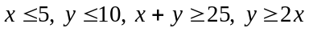
- 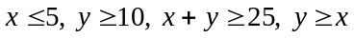
- 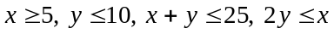
- 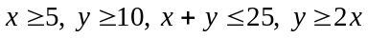
- 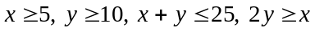

Module 4: Business-related mathematics

If you choose this module all questions must be answered.

Question 1

Renee receives her bank statement for July and notices that it contains an error. The statement is shown below
Date | Transaction Details | Withdrawals | Deposits | Balance
01Jul | Opening balance |  |  | $3537.80
04Jul | Direct credit |  | $145.00 | $3682.80
11Jul | ATM – cash withdrawal | $200.00 |  | $3482.80
15Jul | Interest |  | $1.13 | $3481.67
19Jul | Pay |  | $842.90 | $4324.57
31Jul | Mortgage payment | $386.00 |  | $3938.57

Which one of the following was the incorrect entry made?

- $3 682.80
- $3 482.80
- $3 481.67
- $4 324.57
- $3 938.57

Question 2

Kerry sold an investment property and made a capital gain of $86 000. The rate at which she is charged capital gains tax is 32.5%.
The amount of capital gains tax Kerry had to pay is

- $279.50
- $2 795
- $5 805
- $27 950
- $58 050

Question 3

In a large department store, stock is discounted by 25% for the New Year sales. Stock that remains unsold is discounted a further 10% on the sale price in February and any remaining unsold stock is discounted a further 15% on it's already twice discounted price in March.
The price in March, of a handbag with a price tag of $240 prior to the New Year sales, would be

- $45.90
- $120.00
- $137.70
- $168.30
- $186.30

Question 4

Andy invests $18 000 for 7 years at an interest rate of 6% per annum compounding each quarter. The value of Andy’s investment after 7 years is closest to

- $19 977.21
- $27 310.00
- $47 880.36
- $63 421.53
- $92 010.36

Question 5

Andrew and Olivia each invested $500. Andrew deposited his in an account that earned annual interest of 4% compounding annually and Olivia deposited hers in an account that earned annual simple interest of x%.
At the end of 10 years they had each earned the same amount of interest.
The value of x is closest to

- 0.4
- 4
- 4.2
- 4.8
- 14.8

Question 6

A motor depreciates in value by $46 for every thousand times it is switched on. After 4 years it's value is $12 050 after it has been switched on 72 500 times.
The original value of the motor was

- $3 335
- $8 715
- $15 385
- $45 400
- $3 347 050

Question 7

Marita takes out a car loan for $52 000. The interest rate is 8% per annum compounding half yearly and Marita makes half yearly payments of $4 500.
The time, in years, it will take Marita to repay the loan is closest to

- 7.9
- 6.6
- 12.1
- 13.3
- 15.8

Question 8

Bernadette invests $94 000 in an annuity that returns interest compounded monthly. Bernadette receives monthly payments from the annuity of $953.41 for 15 years. The annual interest rate for this annuity during the 15 years remains the same and is

- 0.75%
- 2.1%
- 4.5%
- 9.0%
- 12.2%

Question 9

Jonathan takes out an “interest only” loan of $180 000. The term of the loan is 5 years and at the end of this period Jonathan is contracted to pay back the principal amount of $180 000.
During the loan Jonathan makes quarterly repayments and the annual interest of 6% is compounded quarterly.
Jonathan’s quarterly repayments are

- $2 700.00
- $3 741.27
- $10 484.23
- $12 121.70
- $18 268.46
Module 5: Networks and decision mathematics

If you choose this module all questions must be answered.

Question 1

Which one of the following is a complete graph?

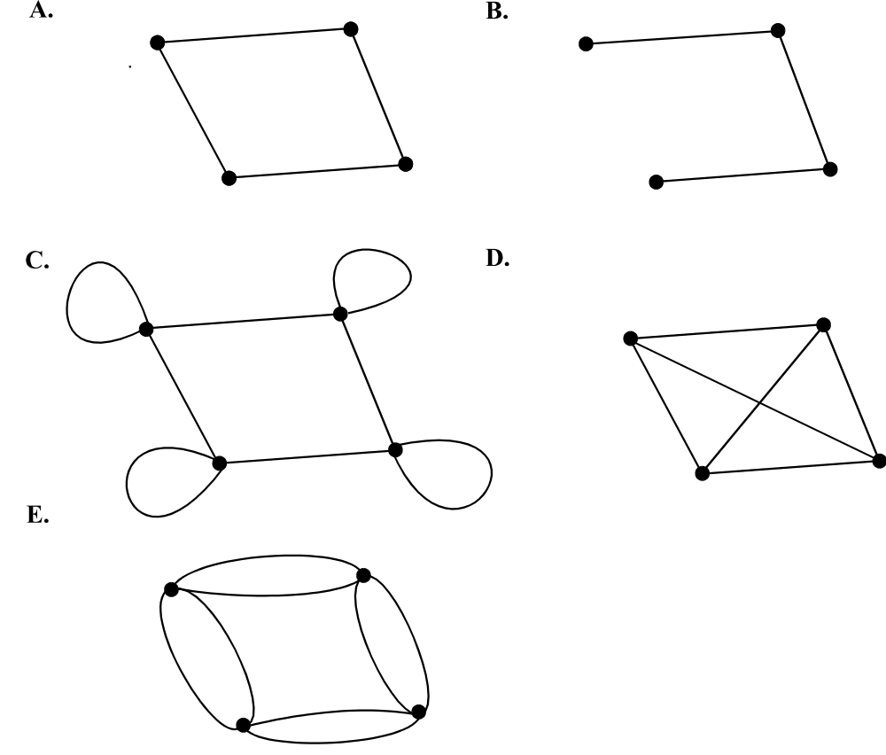

Question 2

The bipartite graph below shows the sports each of four students have chosen

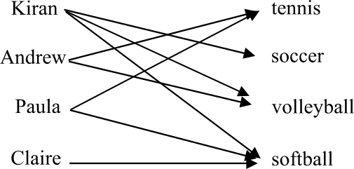

If one of the students is to be allocated to one sport only then a possible allocation would be

B.
Kiran | soccer
Andrew | volleyball
Paula | tennis
Claire | softball

Kiran | tennis
Andrew | soccer
Paula | softball
Claire | volleyball

D.
Kiran | softball
Andrew | tennis
Paula | soccer
Claire | volleyball

C.
Kiran | tennis
Andrew | soccer
Paula | volleyball
Claire | softball

E.
Kiran | volleyball
Andrew | soccer
Paula | tennis
Claire | softball

Question 3

A connected, planar graph has 13 faces and 16 edges. The number of vertices it has is

- 3
- 5
- 12
- 27
- 31

Question 4

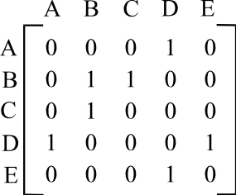

Which one of the following graphs could have as its adjacency matrix the matrix shown above?

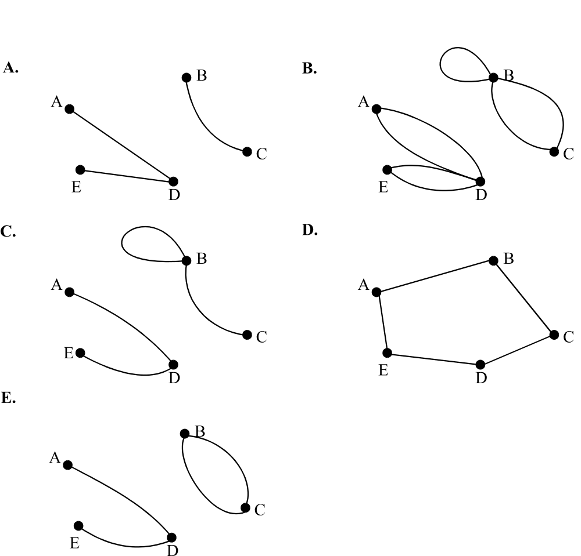

Question 5
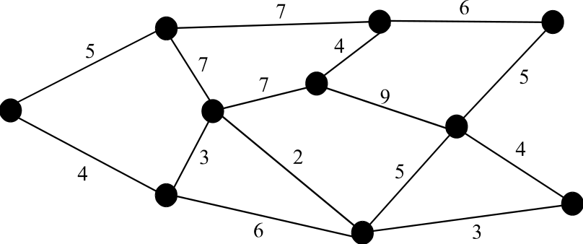

For the graph above, the total weight on the minimum spanning tree is

29
- 34
- 36
- 38
- 41

Question 6

The graph below represents a one-way system of transport.

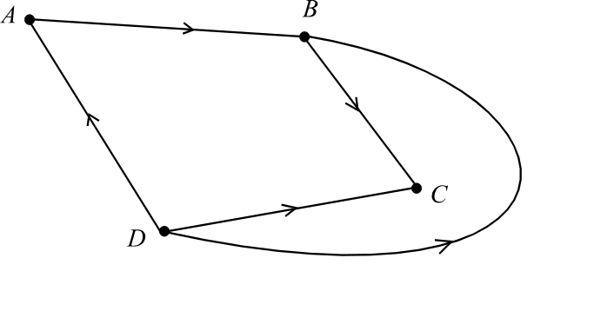

Which one of the following matrices shows the one and two-step reachability of each of the places A – D?

- 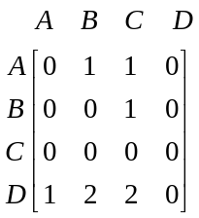
B. 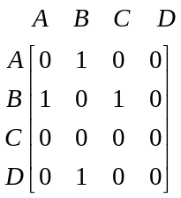

D. 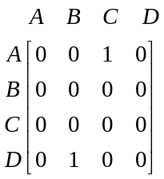

C. 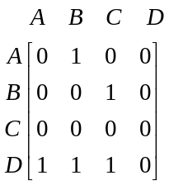

E. 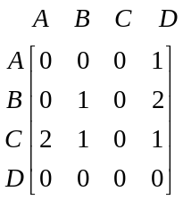

Question 7

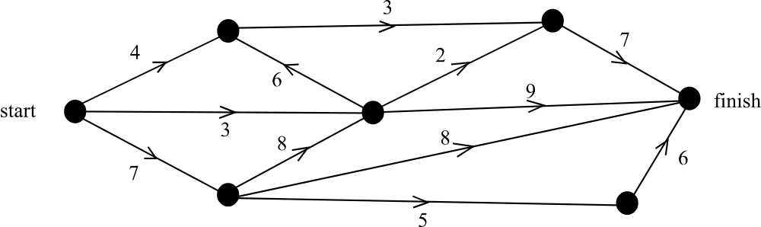

The numbers on the edges of the directed graph above give the maximum flow possible through each of the edges.
The maximum flow possible through the network is

- 7
- 11
- 13
- 14
- 15

Question 8

The network below shows 11 activities; together with the time it takes in days to complete them, to complete a project.
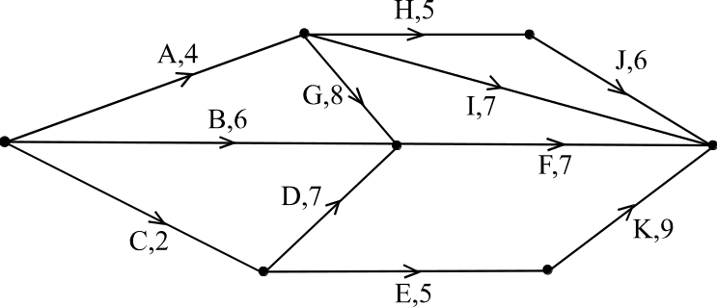

The critical path for this project has a length of

13 days

14 days
- 16 days
- 19 days
- 21 days

Question 9

The graph below shows the results of a tennis tournament that involved four teams.
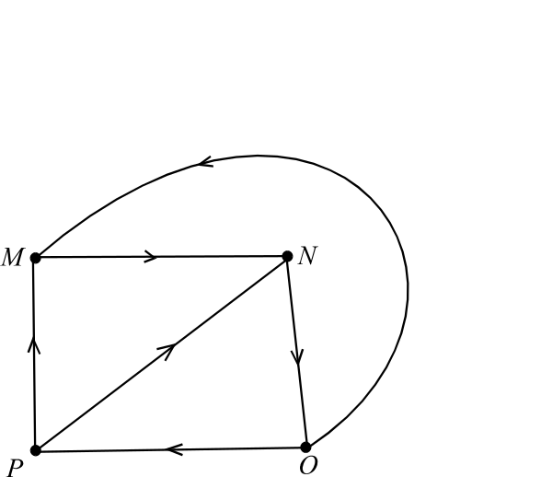

Taking into account one and two step dominance, the dominance score for team O was

2
- 3
- 4
- 5
- 6

Module 6: Matrices

If you choose this module all questions must be answered.

Question 1

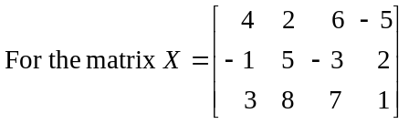, the product of element 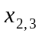 and element 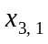 is

- – 9
- – 6
- 0
- 24
- 48

Question 2

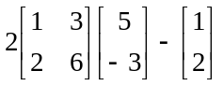 is equal to

- 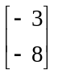
- 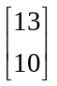
- 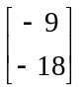
- 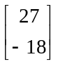
- 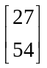

Question 3

If 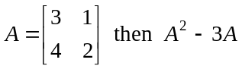 is

- 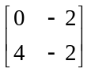
B. 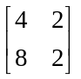

C. 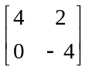
D. 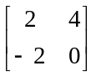

E. not defined.

Question 4

If 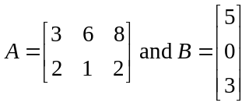 then the order of the matrix product AB is

- 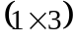
- 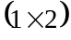
- 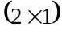
- 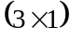
- not defined

Question 5

If 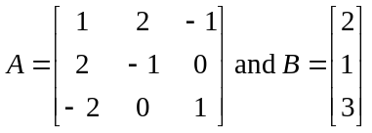 then the matrix product AB is

- 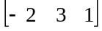
B. 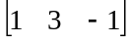

C. 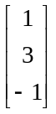
D. 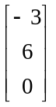

E. not defined.

Question 6

The table below shows an inventory sheet for a warehouse that stores tyres.

February | Tyre
Status | XRT | XRT40 | XRT80 | Totals
inhouse | 242 | 312 | 187 | 741
delivered to dealers | 73 | 105 | 72 | 250
on order | 150 | 200 | 120 | 470

The matrix that shows the number of XRT, XRT40 and XRT80 tyres delivered to dealers during February is

- 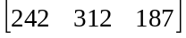
B. 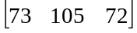

D. 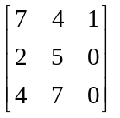

C.

E. 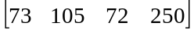

Question 7

Consider the following system of linear equations.

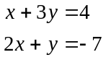

Using matrices to solve this system, the solution would be obtained by evaluating the product.

- 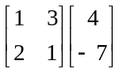
B. 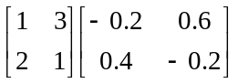

D. 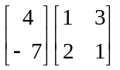

C. 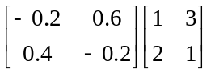

E. 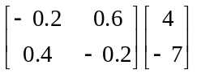

Question 8

The number of chocolate cakes, banana cakes and apple cakes sold at a cake shop each week is described by the matrix

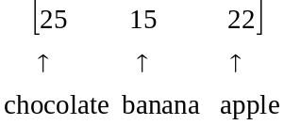

The profit made on each of the cakes is the same and is $4.
Which one of the following gives the total profit made in a week by the sale of the chocolate, banana and apple cakes at this shop?

- 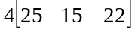
B. 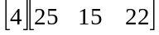

D. 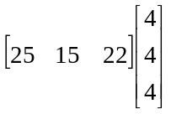

C. 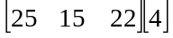

E. 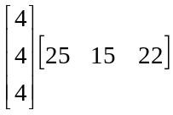

Question 9

For the matrix equation 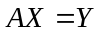

where 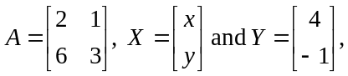which one of the following statements is true?

- The matrix equation has a unique solution.
- The matrix 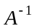 exists.
- 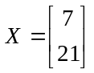
- The product AX is defined.
- The inverse matrix 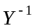 exists.

Further Mathematics Formulas

Core: Data analysis

standardised score: 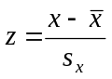
least squares line: 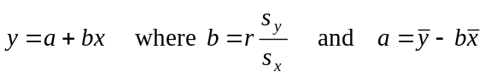
residual value: residual value = actual value – predicted value

seasonal index: seasonal index 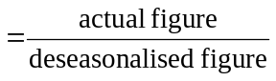

Module 1: Number patterns

arithmetic series: 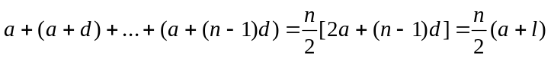
geometric series: 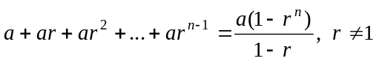
infinite geometric series: 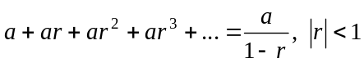

Module 2: Geometry and trigonometry

area of a triangle: 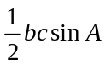
Heron's formula: 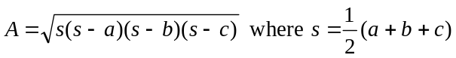
circumference of a circle: 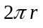

area of a circle: 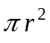

volume of a sphere: 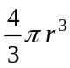
surface area of a sphere: 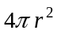

volume of a cone: 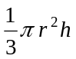
volume of a cylinder: 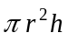

volume of a prism: 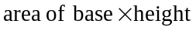
volume of a pyramid: 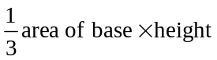

Reproduced with permission of the Victorian Curriculum and Assessment Authority, Victoria, Australia.
These formula sheets have been copied from the VCAA website www.vcaa.vic.edu.au
The VCAA publish an exam issue supplement to the VCAA bulletin.
Pythagoras’ theorem 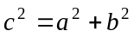

sine rule: 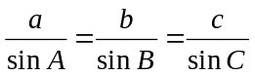
cosine rule: 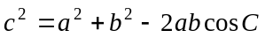

Module 3: Graphs and relations

Straight line graphs
gradient (slope): 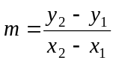
equation: 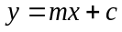

Module 4: Business-related mathematics

simple interest: 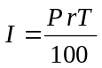
compound interest: 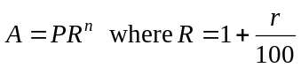
hire purchase: 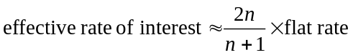

Module 5: Networks and decision mathematics

Euler’s formula: 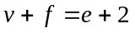

Module 6: Matrices

determinant of a 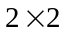 matrix 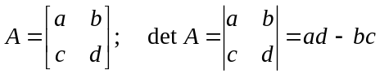
inverse of a matrix 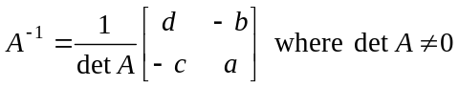

END OF FORMULA SHEET

Reproduced with permission of the Victorian Curriculum and Assessment Authority, Victoria, Australia.
These formula sheets have been copied in 2006 from the VCAA website www.vcaa.vic.edu.au
The VCAA publish an exam issue supplement to the VCAA bulletin.

